Behavioural Observation Instructions and Guidelines

First shift Second shift All night follow
17:00- 23:30 23:00- till loris enters sleep site 17:00- till loris enters sleep site

What to take to the field:
SIKA receiver | GPS | Red filter
Antenna | Head torch | Binoculars/ Sony handycam camera
Clipboard | Data collection sheets | Ethogram
Waterproof notepad  Laser rangefinder | Spare batteries | Large torch (if needed)

On the sign out sheet on the door of the equipment room write down: your name, date, time signed out and signed in and list the equipment items taken out.
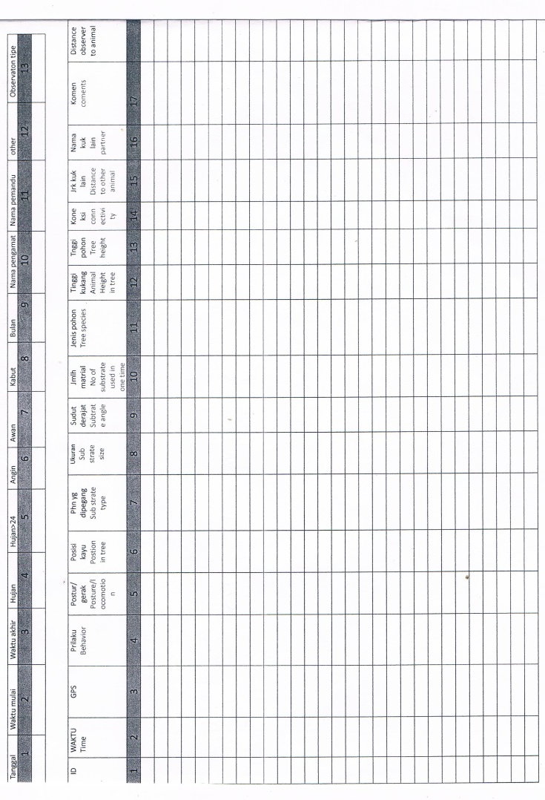
When returning from the field put all equipment that needs charging on charge incl. batteries.
Sample Data Collection Sheet

GPS
Enter the codes as follows:
Loris initials, GPS point number, space, observer intials
Eg.: Lucu
LU001 DS
Pak Bulan has made an appearance and starts from 001, but Lucu continues at 004. The next day that you observe either of them you start again from 001, you do not continue from the number you left off.
LU002 DS
LU003 DS
PB001 DS
LU004 DS

Take a GPS point of a focal loris every 15 minutes. Additionally, take GPS points of any other lorises, civets (check species), leopard cats or other mammals seen whilst out in the field.

Observations
When you see a loris- MAKE SURE YOU USE RED LIGHT! Do not use white light to observe the loris.

Check on the weekly schedule (on the white board) which loris you are assigned to for your shift.

First things first: (top of the data collection sheet)

These are all filled in at the start of the observation! Check your ethogram for the categories and remember to fill in the time you finish the behavioural observation at the end of the shift- not if you move to another individual.
Indonesian | English
Tanggal | Date
Waktu mulai | Start time
Waktu akhir | End time
Hujan | Rain
Hujan <24 | Rain in last 24 hours
Angin | Wind
Awan | Cloud
Kabut | Fog
Bulan | Moon (phase)
Nama pengamat | Name of observer
Nama pemandu | Name of tracker

How and What to Record
Behaviour: Refer to the behaviours on the ethogram. If you cannot see the animal, eg. it is in bamboo but the signal indicates that it is there, record as OOS (out of sight). If you can see only eyeshine, record as Hidden. If you are not sure/ the behaviour does not fit into any other the categories put Other and describe what you have seen in the comments box.
ID: Write the loris initials as indicated on the ID sheets.
Example:
Lucu – LU
Toyib - TO

Posture/locomotion: Refer to the sheet with all the drawings of the various postures. If you are not sure or cannot see the animal- leave blank.
Time:
- Data on all categories are collected every 15 minutes preferably on a multiple of 5 ie. 23:05, 04:55, 18:25
- Data on any interesting behaviour is recorded and the duration is written ie. Start time and the time the behaviour finishes/ the loris starts a new behaviour.

23:15 Fill in all categories
23:17 Special behaviour: loris feeding on K. merah with right hand
23:18 Changes to feeding on K. merah with left hand
23:19 Resting
23:30 Fill in all categories

Position in Tree: Refer to ethogram. Also record if only the eyeshine of the animal is visible. If not certain, leave box blank.
Substrate Type: Refer to ethogram. If the animal is not in sight or only the eyeshine is visible do not record (leave box blank) unless certain.

90
Substrate Size:
Small (1)
Medium (2)
Large (3)
Leave the box blank if you only see eyeshine or you cannot be sure.
Substrate angle:

#’]’?~
90
45
Number of Substrates used at one time:
0 – All four limbs are on the same substrate
1 - Limbs are touching more than one substrate.

0
-90
-45
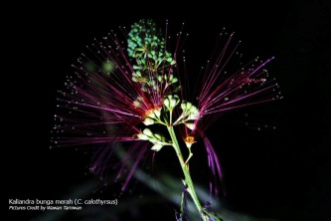
Tree species: Always double check the tree species with your accompanying tracker.
Eg. Kaliandra merah

Animal Height in Tree and Tree Height: These are estimates heights. Only record if the base of the tree is visible. If the base of the tree is not visible- leave boxes blank.

Connectivity:
0 – The tree which the loris is using is isolated. It is not connected to any other trees.
1 - The tree which the loris is using is connected to one or more other trees. The loris would be able to move between the trees without having to come to the ground.
Distance observer to animal: Estimate the distance between where you are sitting observing the animal and where the animal is. Use a laser rangefinder when possible. Try and keep a minimum distance of 15-20m where possible.
Partner: Initials of the other animal that is close to the loris being observed. If the animal has no collared use the initials UN unless it is a baby, then use the initials UB.
Distance to other animal: Distance is measured in meters. It is an estimated distance unless the observer has brought a laser rangefinder.
#’]’?~

What do you do when you see another loris?
When you have not yet found the focal individual eg. as you are walking through the study area
Check if the loris is an adult or infant
Check if the loris has a radio collar. If uncollared mark on GPS as an uncollared loris/ uncollared baby loris. If collared check with the radio tracker which loris it is. Mark on the GPS. Collect any data that is possible for at least one data point. Do not spend more than 15 minutes with the animal unless the animal is engaged in an interesting behaviour.
When you are watching the focal individual
Check if the loris is collared or uncollared/ baby or adult. Mark on GPS.
If another loris comes into view whilst you are watching your focal loris
- If they are both in the same line of sight, try and take data on both of the lorises. If you are not comfortable doing this, ask the tracker/partner you are with to watch and collect data on one of the lorises whilst you watch the other. Take GPS point every 15 minutes of both animals.
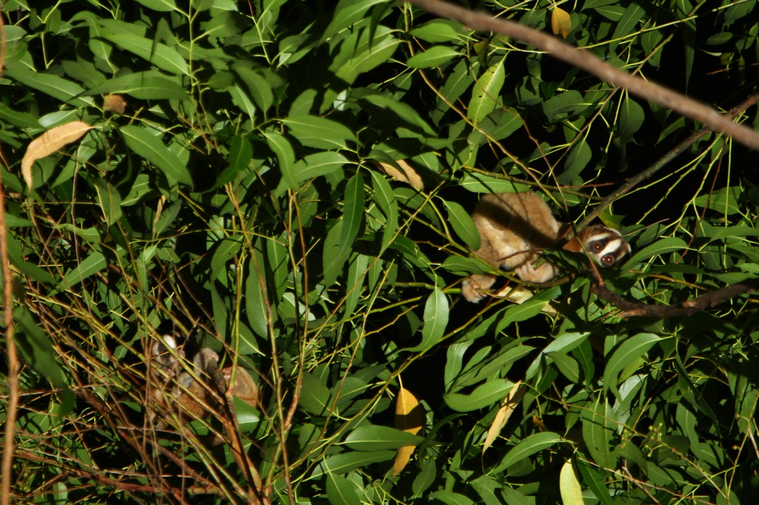
- If the loris is not in the same line of sight as your focal animal eg. behind you. Keep watching your focal animal and write the distance between the two animals. Every 15 minutes scan the new individual and enter the data into the data collection sheet. Take a GPS point every 15 minutes of both animals.

What do you do when you see another animal eg. civet, leopard cat…?
When you have not yet found the focal individual eg. as you are walking through the study area
Identify the species and mark using a GPS
Collect any data that is possible until you lose sight of the animal. Collect data on position in the tree/on the ground, behaviour with comments on anything interesting and make a note of the habitat- was the animal sighted in a field (what type of crop), close to a river or path (estimated distance). Take GPS points every 15 minutes for the duration of the time observed.
When you are watching the focal individual
Identify the species and mark using a GPS
Have the person accompanying you (tracker or partner) take behavioural data on the other animal sighted. They should collect any data that is possible until they lose sight of the animal. Collect data on position in the tree/on the ground, behaviour with comments on anything interesting and make a note of the habitat- was the animal sighted in a field (what type of crop), close to a river or path (estimated distance). Take GPS points every 15 minutes for the duration of the time observed.
You keep watching the loris (your focal animal) as it may show a behaviour change in response to the other animal sighted. We want to record this. Note the distance between the loris and the other animal. Write down any interesting behavioural or vocal responses eg. anointing, travelling, freeze…

Remember very little is known about civets, leopard cats, linsangs, binturongs… so please collect data!

How long do you wait when an animal has moved?
When an animal moves away- you wait 15 minutes before attempting to follow that individual. This is so that the animal does not feel chased and therefore the presence of the observer does not add extra stress. After 15 minutes you attempt to find the individual again.

What to do when you know the animal is there but you cannot see it?
When you have tracked the animal in a patch of bamboo for example but you cannot see it you wait for 30 minutes to see if the animal will show itself. During this 30 minutes you may walk around to check the different sides of the patch to see if there is greater visibility elsewhere. After 30 minutes you have not seen the animal you wait another 30 minutes and attempt to find the animal. If after one hour the animal has not been sighted you move on to another animal.

What do you do in case of heavy rainfall?
If it starts raining very heavily you seek cover. There are several famers’ huts in the study area where you can shelter. You wait for 30 minutes. If in that 30 minutes the rain stops you recommence the observations. If it is still raining heavily, you wait another 30 minutes. If during that period the rain stops or it is raining a little you recommence the observations. However, if it is still raining heavily, you can quite the observations and head back to the field station. This only applies to heavy rain. In the case of little rain, the observations continue with the use of a waterproof notebook and pencil.
What do you do in case of thick fog?
If a thick fog rolls in, minimizing visibility you do NOT continue the observation with white light to increase visibility. Instead, you halt the observation and stay where you are. You wait for 30 minutes for the fog to clear. If the fog clears, you recommence the observations. If the fog does not clear, you wait an additional 30 minutes. If the fog clears in that time you recommence the observations. After 1 hour if the fog has not cleared, you may quite the observation and head back to the field station.

