1. Abiotic & General Data Variables
Variable | Categories | Details
Date |  | Date of the day. Important: the date of one night stays the same after 0:00!
Starting time |  | First contact with animal minus 5 minutes
End time |  | Leaving the animal. Please note down time when leave and find new animal if you swap animal during the night.
Observer |  | Researcher, volunteer (person collecting data)
Assistant |  | Tracker
Others |  | Other people
Observation type | Normal observation | Per individual, to be added when inserting data
 | Capture
 | First sighting
 | Transect
Loris |  | Name of loris
Rain | No | If it starts raining during observation please continue observing as long as possible (as otherwise it creates bias); if you seek shelter, wait at least 1-2 hours if the rain stops before you decide to go home
 | Little: Drizzle
 | Medium: continuous
 | Strong: getting wet quickly
Rain last 24 hours | See rain
Wind | No
 | Little: Leaves are moving clearly
 | Medium: branches are moving
 | Strong: Small trees are bending
Cloud |  | 10 % steps of cloud cover, may later be converted into broader categories
Fog | No | And in meters until fog is visible, may later be converted into broader categories
 | Little: >15 m
 | Medium: 5-15 m
 | Strong: < 5m
Moon |  | 10 % steps, later more precise using the moon phase

2. Ethograms
Behaviour
 | Behaviour | Definition
1 | Alert | Remain stationary like in “rest” but active observation of environment or observer
2 | Feed | Actual consumption of a food item
3 | Forage | Movement associated with looking for food (often includes visual and olfactory searching) or any other stimulus (scent marking etc.)
4 | Freeze | Interrupt locomotion to maintain motionless, rigid posture in standing or sitting  position for at least three seconds, extremely slow movement not associated with foraging
5 | Groom | Autogroom, lick or use tooth comb on own fur
6 | Rest | Remain stationary, often with body hunched, eyes open
7 | Sleep | Remein stationary, head between the knees, eyes closed
8 | Social | All interactions with conspecifics, including aggression, allogroom, play and other social behaviours
9 | Aggression | Fight, bite including attempts, threat, chasing; often accompanied agonistic vocalisations
10 | Allogroom | Lick or comb with toothcomb other loris’ face or fur - usually while clasping him or her
11 | Play | Behaviours serving no immediate, definable purpose, including friendly attempted bite or manual attack and clasping, dangle by feet, wriggle body with arms over  head. No vocalisations as when fighting.
12 | Other social | Social activity while being in contact or close proximity (<5 m), like mating, social follow, sniffing, social explore
13 | Travel | Continuous, directed movement from one location to another
14 | Out of Sight | Behaviour cannot be seen (eyes may be seen)
15 | Other | Other behavior not included above

- Posture/Locomotion
Posture/Locomotion | Definition
Posture
- Sit | Remain stationary with body hunched and head erect
- Stand | Remain stationary in upright position using all four limbs
- Suspension 1 | Hanging from one foot (rare but can occur when playing)
- Suspension 2 | Hanging from two feet
- Suspension 3 | Hanging from three feet
- Suspension 4 | Hanging from four feet
- Vertical suspension 2 | Hanging towards the side of a support, with 2 feet (e.g. when exploring/observing)
- Vertical suspension 3, up or down (2 different categories) | Hanging towards the side of a support, with 3 feet, either facing upwards or downwards
- Vertical suspension 4, up or down (2 different categories) | Hanging towards the side of a support, with 4 feet, either facing upwards or downwards
- "Schlafkugel" (sleeping ball) | Remain stationary with body hunched and head erect, head between the knees
Locomotion
- Walk | Quadrupedal walking on support
- Suspensory Walk | Locomoting while hanging from 0 degree or +/- 45 degree support
- Climb Up | Moving upwards on support
- Climb Down | Moving downwards on support
- Bridge | Climbing from one support to the next, stretching over a gap of more than 15 cm
- Climb Horizontally | Moving horizontally through +/- 90 or +/- 45 degree support

Posture/Locomotion
Posture
- Sit
- Stand
- Suspension 1 | 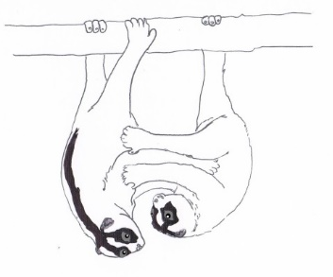
- Suspension 2
- Suspension 3
- Suspension 4
- Vertical Suspension 2

- Vertical Suspension 3,  up or down  (2 different categories) | Like vertical suspension 4 (see below), just with 3 limbs attached
- Vertical suspension 4, up or down (2 different categories)

- "Schlafkugel" (sleeping ball) | 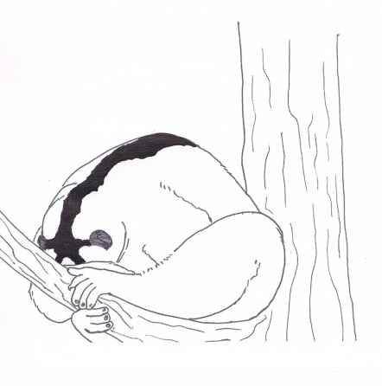
Locomotion
- Walk
- Suspensory Walk

- Climb Up | 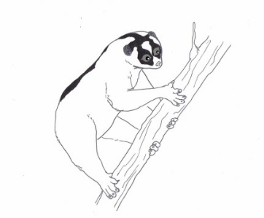
- Climb Down | 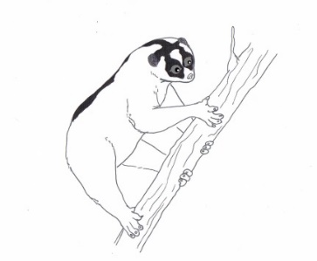
- Bridge | 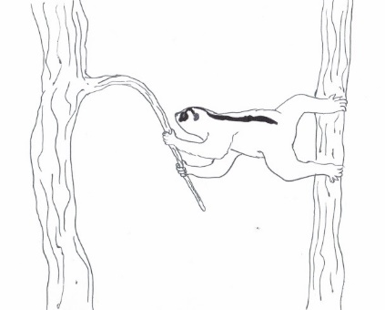
- Climb Horizontally | 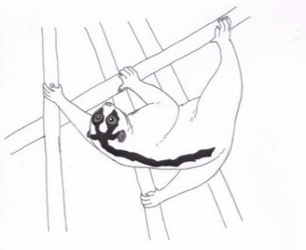

- Position
Number | Category | Definition
0 | Periphery | Leaves and terminal branches
1 | Central | Inner part of the canopy (inner ¾ of tree crown radius)
2 | Crown | Periphery on top of the tree, < 2 m from top
3 | Trunk | On or near the trunk (<1m)
4 | Undergrowth | In bushes and grass lad of < 3m
5 | Terrestrial | On the ground
6 | Water line | On water pipes or pipe support leading over the fields
7 | Labu | Using labu or labu support structures (typically bamboo)
8 | Other
 | Picture
 | Trunk | 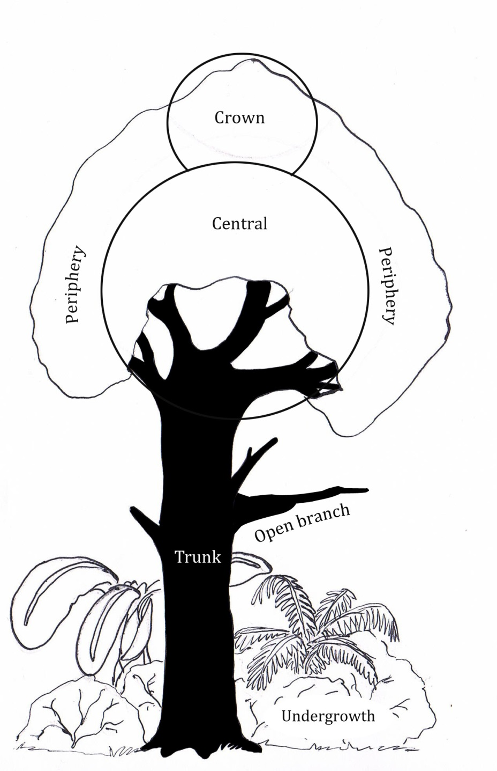
 | Central
 | Crown
 | Periphery
 | Undergrowth
 | Terrestrial
 | Open branch
 | Water line

- Substrate Type
Category | Number
Trunk | 1
Bamboo Trunk | 2
Branch | 3
Terrestrial | 4
Water Line | 5
Banana | 6

- Support size
Number | Category | Definition
1 | Small | Loris can fully grip the branch, <2 cm diameter  (average hand span is 5.8 cm)
2 | Medium | Hand of the loris can curve around the branch, 2<x<10 cm diameter (hand can span between 1/4 and 1/5 of the support diameter)
3 | large | Hand is flat on the branch/trunk, > 10 cm diameter

Category
Small | 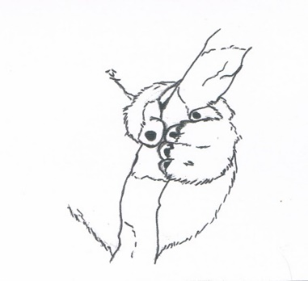
Medium | 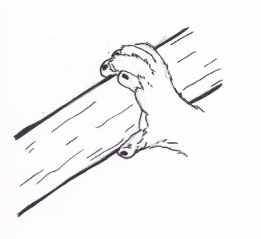
large

- Support angle
Category
0 | 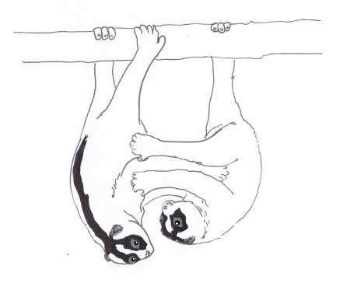
+45 | 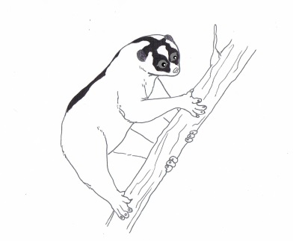
-45
+90
-90

