Identification band  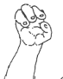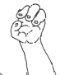  R L  Hands |  | Day of trapping |  |  |  | GPS location, habitat (mark tree!)
 |  | MC ID
 |  | Number/ID |  | Sex |  | Age |  | Photo numbers
 |  | Observer, assistant |  |  |  |  |  |  | Colour code
 |  | Reaction during capture
Weight |  | Weight: <450g infant, 450-675g subadult, >675 adult, + fur, + wear of teeth and nails |  |  |  | Notes
Body length (neck to base of tail) |  | Tail
Head length |  | Muzzle length
Head width
Lngth LT testicle | Lngth RT testicle |  | Width LT testicle |  | Width RT testicle |  | Width both testes together
State of vagina (clos/op/swollen) |  | Reproduction status (enlarged nipples, swollen/milk nipples/sexual testes)
RT |  | LT |  |  |  | Tick:  O Ectoparasites  O Gland exudates  O Saliva  O Urine  O Feces  O Cut some hair  (mark with ID-DD/MM/YY)
Ear length
Ear width
Hand span
Hind foot span
Leg
Arm
Chest girth
Neck girth
Colour of nose |  |  |  |  | Hair length
Colour of Facemask (orangish, brownish, blackish) |  |  |  |  | Width of face stripes (thick, medium, thin)
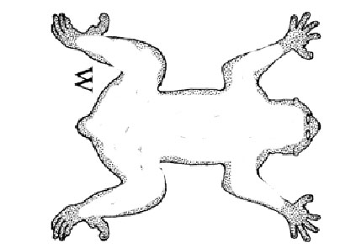
Dorsal stripe
Which vertebrate area:
X
X
X
X
Thick / jaggy / straight /

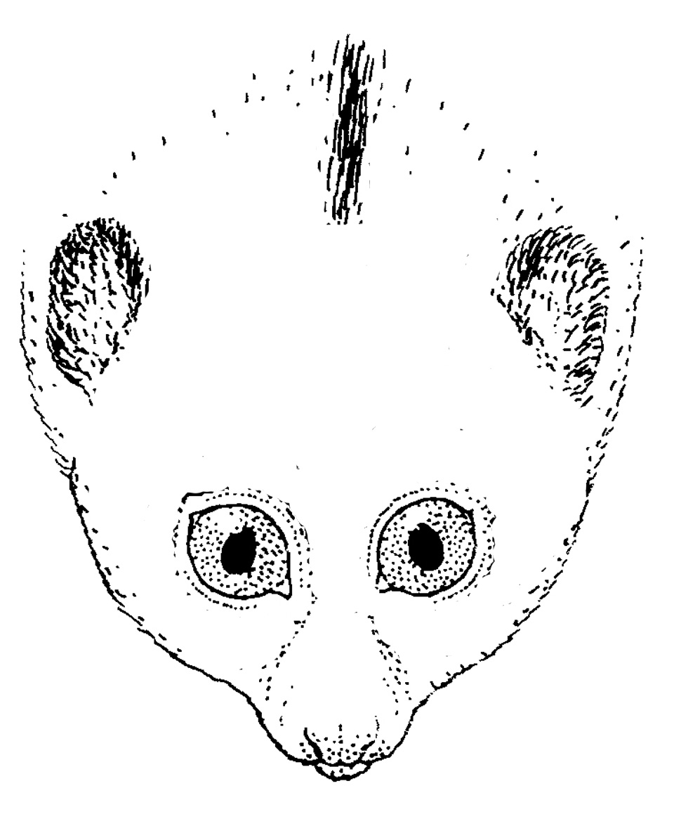
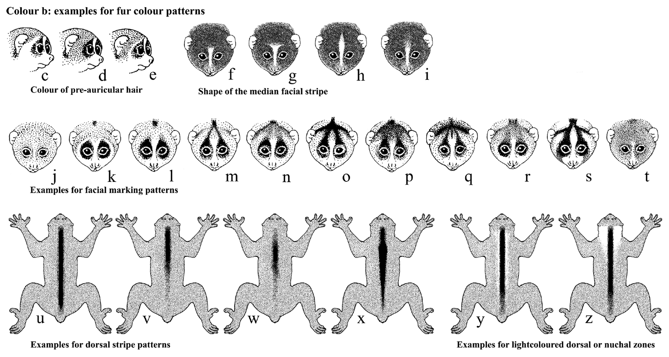
Facial pattern
Condition of ears  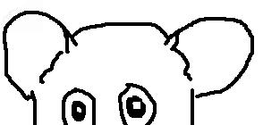  R L |  |  |  |  | Other identification signs (e.g. wounds)

