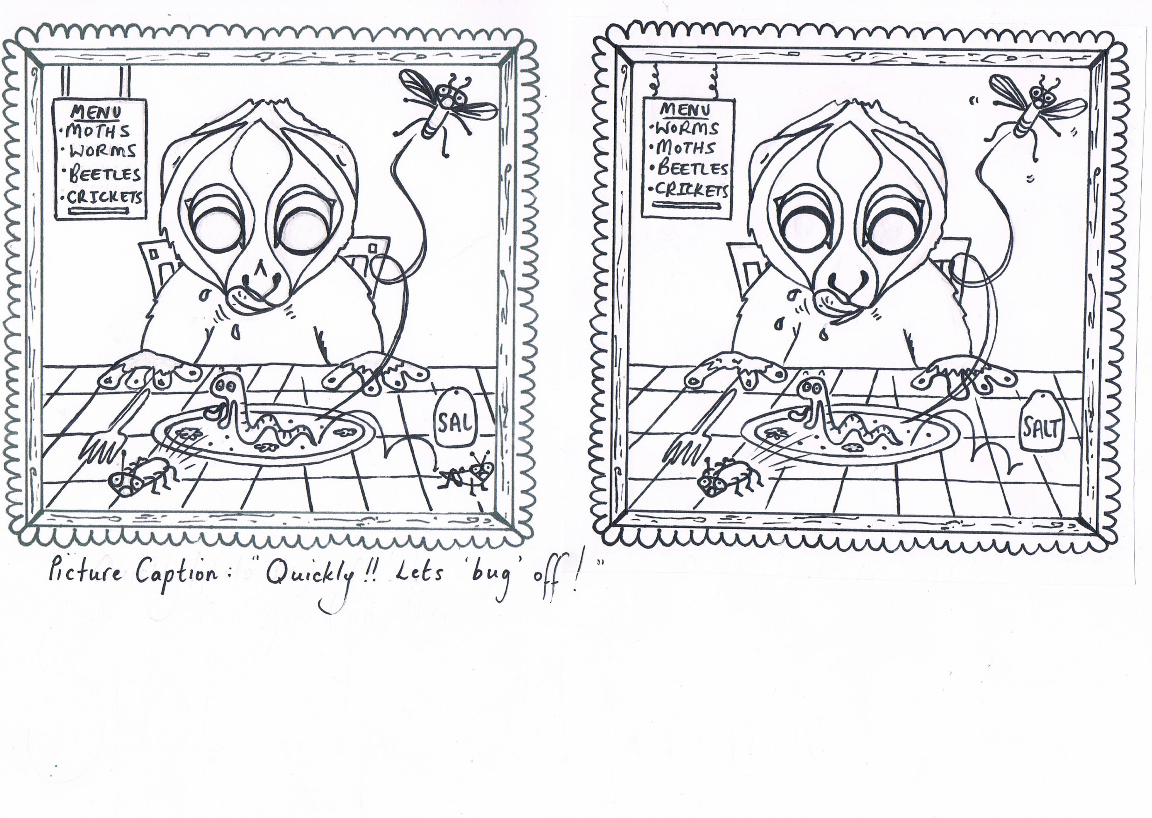

Story and drawings by Charlotte Young

**SPOT THE DIFFERENCE!**

**CAN YOU SPOT THE 15 DIFFERENCES BETWEEN THESE TWO PICTURES?**

When Bunga woke up, for a night full of Loris fun, his tummy let out an almighty **GRUMBLE!!**

‘’I’m really hungry!’’ cried Bunga.

Taking a moment to think what to do about his very grumbly tummy he remembered something…

‘’It’s Friday! I can go to Bamboo Bill’s, a very special slow loris restaurant and he’ll make me something yummy’’

Bunga was just right in his thinking and when he arrived Bamboo Bill brought him a very yummy dinner indeed. A plate full of INSECTS!

‘’My favourite food cried Bunga!!’’